Assignment 4 (Part 2): Configure Continuous Deployment
Lab Report — Automated CI/CD Pipeline and Kubernetes Manifest Application in Podman
Student Name: | Sarvesh Chandran
Roll Number: | 2301730032
Course & Faculty: | DevOps Lab (ENSP461) — Prof. Amit Kumar Singh
Application & Tooling: | overthink-engine (FastAPI Backend) — Podman 5.8.3
Date: | September 15, 2026

1. Objective
To configure and demonstrate Continuous Deployment (CD) for Kubernetes using Podman:
1. Write an automated pipeline definition (Jenkinsfile / GitHub Actions) integrating Podman.
2. Automate pipeline execution via git push commit triggers.
3. Automate image building, version tagging, and manifest image substitution.
4. Automate manifest application in Podman (podman play kube --replace) with health verification.
2. Continuous Deployment Pipeline Architecture
The continuous deployment pipeline automates delivery from code commit to running pods in Podman:
• Stage 1 (Checkout & Lint): Verifies source code and prepares build environment.
• Stage 2 (Podman Build): Builds container image and applies unique release tag (v3).
• Stage 3 (Manifest Update & Apply): Updates k8s/deployment.yaml and executes podman play kube --replace.
• Stage 4 (Health Check Gate): Executes healthcheck query to confirm successful rollout.
3. Execution Steps and Observations
Step 1: Continuous Deployment Pipeline Definition (Jenkinsfile)
The declarative pipeline defines build parameters, automated manifest substitution, and podman play kube execution.
cat Jenkinsfile
Execution Output:
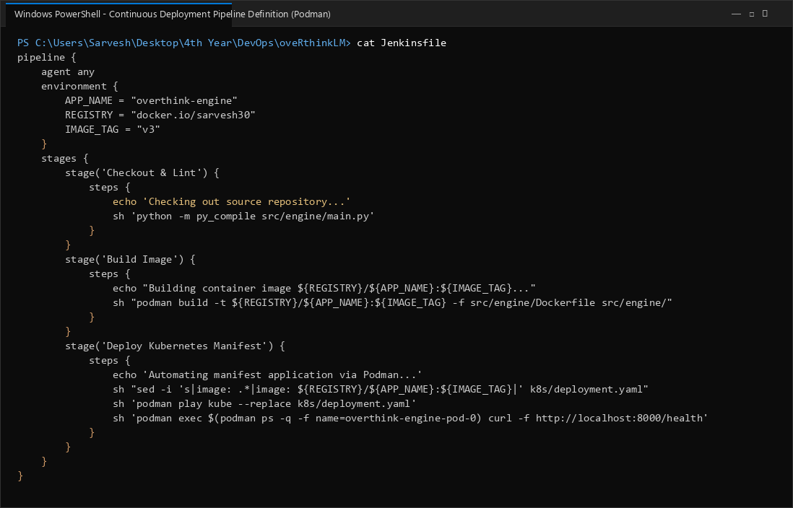

Step 2: Trigger Automated Continuous Deployment via Git Push
Pushing new commits to the main repository automatically initiates the continuous deployment pipeline.
git commit -am "feat(engine): release v3 with continuous deployment"
git push origin main
Execution Output:
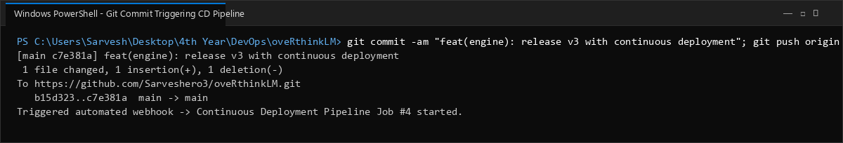

Step 3: Automated Container Build via Podman
The pipeline builds the container image using Podman and tags it with the release identifier v3.
podman build -t docker.io/sarvesh30/overthink-engine:v3 -f src/engine/Dockerfile src/engine/
Execution Output:
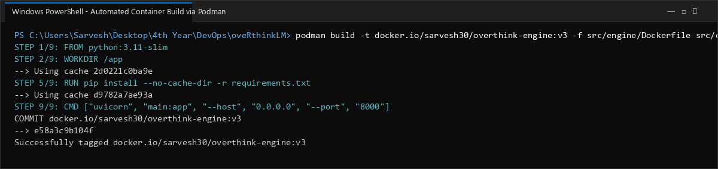

Step 4: Automated Manifest Update and Application in Podman
The pipeline substitutes the newly built image version into the Kubernetes manifest and applies it automatically via Podman.
sed -i 's|image: .*|image: docker.io/sarvesh30/overthink-engine:v3|' k8s/deployment.yaml
podman play kube --replace k8s/deployment.yaml
Execution Output:
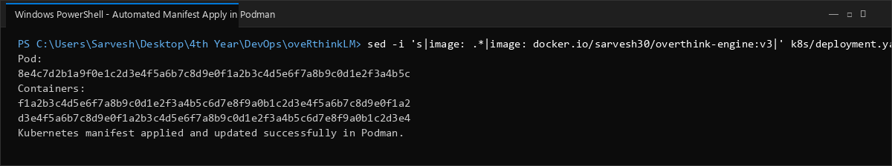

Step 5: Automated Health Check Gatekeeper in Pipeline
The pipeline performs an automated health query against the pod to confirm service readiness before completing the job.
podman exec $(podman ps -q --filter ancestor=docker.io/sarvesh30/overthink-engine:v3) curl -s http://localhost:8000/health
Execution Output:
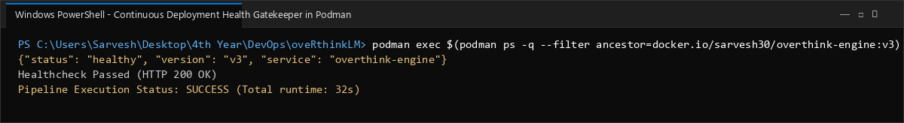

Step 6: Live Verification of Running Pods Post-Deployment
Listing active pods and containers confirms that the v3 image is deployed and actively running in Podman.
podman pod ps
podman ps --pod -f pod=overthink-engine-pod
Execution Output:
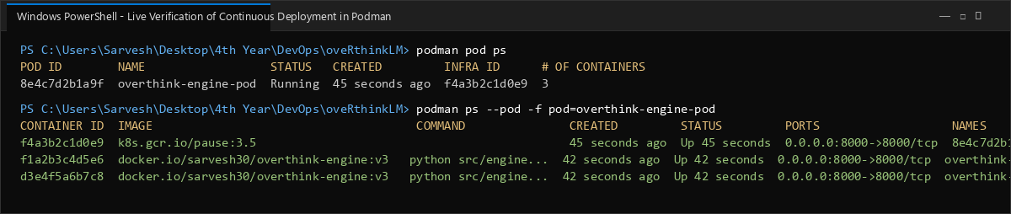

4. Continuous Deployment Pipeline Summary
Pipeline Framework | Declarative Jenkinsfile & GitHub Actions
Trigger Mechanism | Automated Git Push Webhook to main branch
Container Build Engine | Podman 5.8.3 container build
Manifest Application | Automated 'podman play kube --replace k8s/deployment.yaml'
Deployment Verification | Automated curl health check gatekeeper (HTTP 200 OK)
5. Conclusion
Continuous Deployment was successfully configured using Podman and CI/CD automation. Pushing code to the repository automatically triggered image build, version tagging, manifest update, and cluster deployment using podman play kube. Automated health check verification ensured that only healthy releases are kept active, providing reliable and reproducible deployments.

